Covid-19 Data Exploration Project

By Alex Ang

Link to dataset: <https://ourworldindata.org/covid-deaths>

This project is dedicated to sourcing global Covid-19 data spanning the years 2020-2021 with sample data gathered. It serves as the initial step in my journey as a Data Analyst, initiated through participation in an online bootcamp provided by AlexTheAnalyst. This educational experience has equipped me with valuable SQL skills and knowledge. As a result of this bootcamp, I have successfully acquainted myself with SQL and refreshed my understanding of it.

/* Chances of death after contracting covid-19 in Singapore*/

Select Location, Date, total_cases, total_deaths, ((total_deaths/total_cases) * 100) as DeathPercentage

From PortfolioProject..CovidDeaths

Where Location like '%singapore'

order by 1,2

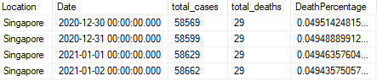

/* Percentage of People Infected in Singapore against the whole of Singapore*/

Select Location, Date, Population, total_cases, ((total_cases/Population) * 100) as Covid_Infected_InSG

From PortfolioProject..CovidDeaths

Where Location like '%singapore'

order by 1,2

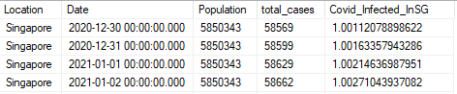

/* Countries with Highest Infection Percentage Rate */

Select Location, Population, MAX(total_cases) as HighestInfectionCount, (MAX(total_cases/Population) * 100) as PercentagePopulationInfected

From PortfolioProject..CovidDeaths

group by location, population

order by PercentagePopulationInfected desc

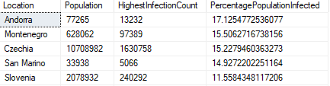

/* Country's total death count from the highest*/

Select Location, MAX(cast(total_deaths as int)) as TotalDeaths

From PortfolioProject..CovidDeaths

where continent is NOT NULL

group by location

order by TotalDeaths desc

/* Each continent's total deathcount */

Select continent, MAX(cast(total_deaths as int)) as TotalDeaths

From PortfolioProject..CovidDeaths

where continent is not NULL

group by continent

order by TotalDeaths desc

/* Global Data */

Select SUM(Population) as TotalPopulation, SUM((new_cases)) as TotalCases, SUM(cast(new_deaths as int)) as TotalDeaths, (SUM(cast(new_deaths as int))/SUM(new_cases))* 100 as DeathPercentage

From PortfolioProject..CovidDeaths

where continent is not NULL

order by 1,2



/* Create View to store data visualization of People vaccinated */

Create View PercentagePopVac as

Select cd.continent, cd.location, cd.date, cd.population, cv.new_vaccinations,

SUM(cast(cv.new_vaccinations as int)) over (Partition by cd.location order by cd.location, cd.date)

as PeopleVaccinated

from PortfolioProject..CovidDeaths cd

join PortfolioProject..CovidVaccinations cv

on cd.location = cv.location

and cd.date = cv.date

where cd.continent is NOT NULL

Select *

From PercentagePopVac

